LAP 1+2 – Thực hành
Nguyễn Ngọc Mỹ Dung
1150080006 – THMT
LAP 01:
Hình Ảnh: 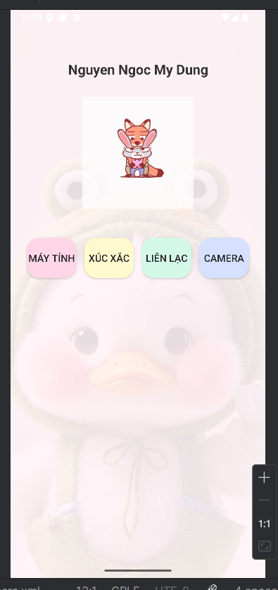
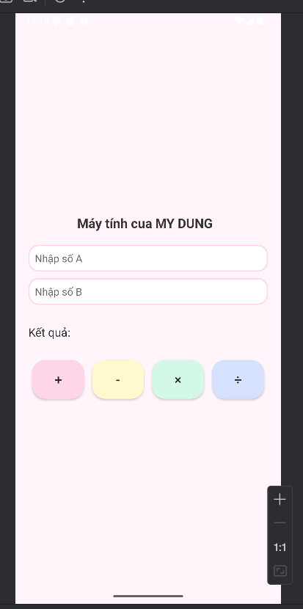
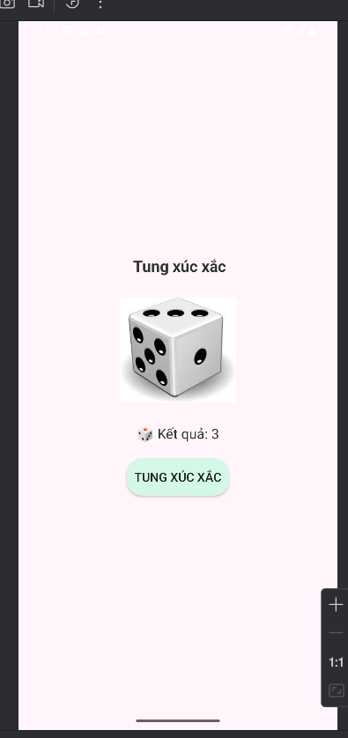
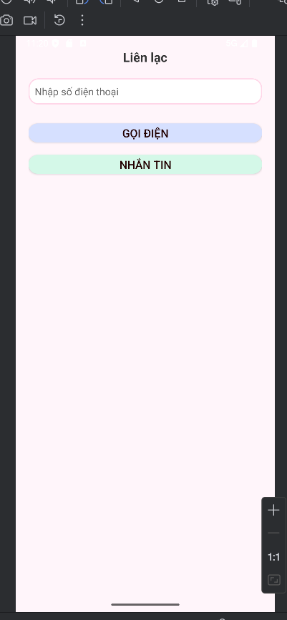
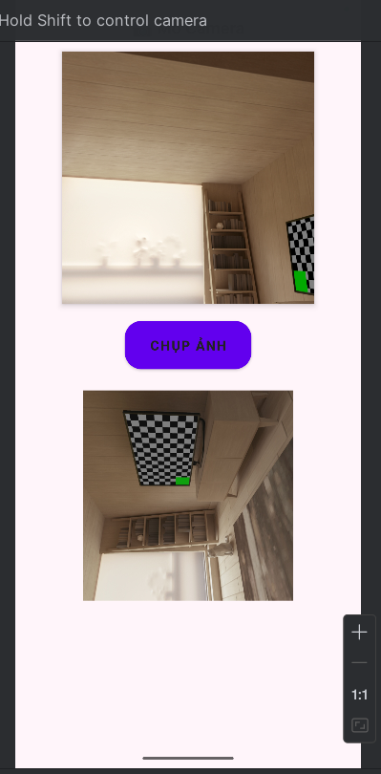
Code:
<?xml version="1.0" encoding="utf-8"?>
<LinearLayout xmlns:android="http://schemas.android.com/apk/res/android"
xmlns:app="http://schemas.android.com/apk/res-auto"
xmlns:tools="http://schemas.android.com/tools"
android:layout_width="match_parent"
android:layout_height="match_parent"
android:background="#FFF5FA"
android:orientation="vertical"
android:gravity="center_horizontal"
android:padding="20dp"
tools:context=".CameraActivity">
<TextView
android:id="@+id/tvTitle"
android:layout_width="wrap_content"
android:layout_height="wrap_content"
android:text="📷 Mở Camera"
android:textSize="20sp"
android:textStyle="bold"
android:textColor="#333333"
android:layout_marginBottom="15dp" />
<androidx.camera.view.PreviewView
android:id="@+id/previewView"
android:layout_width="300dp"
android:layout_height="300dp"
android:layout_marginBottom="20dp"
android:background="#EDEDED"
app:implementationMode="performance"
android:elevation="4dp"
android:scaleType="centerCrop"
android:clipToOutline="true"
tools:background="@drawable/ic_launcher_foreground"
android:outlineProvider="background" />
<Button
android:id="@+id/btnCapture"
android:layout_width="wrap_content"
android:layout_height="wrap_content"
android:text="CHỤP ẢNH"
android:textSize="16sp"
android:textStyle="bold"
android:textColor="#222"
android:paddingHorizontal="30dp"
android:paddingVertical="12dp"
android:layout_marginBottom="25dp"
android:background="@drawable/btn_bg_yellow"
android:backgroundTint="@null" />
<ImageView
android:id="@+id/imgResult"
android:layout_width="250dp"
android:layout_height="250dp"
android:layout_gravity="center"
android:background="#F8F8F8"
android:scaleType="centerCrop"
tools:src="@drawable/ic_launcher_foreground"
android:contentDescription="Ảnh chụp kết quả" />
</LinearLayout>
<?xml version="1.0" encoding="utf-8"?>
<LinearLayout xmlns:android="http://schemas.android.com/apk/res/android"
android:layout_width="match_parent"
android:layout_height="match_parent"
android:background="#FFF5FA"
android:orientation="vertical"
android:gravity="center_horizontal"
android:padding="20dp">
<TextView
android:text="Liên lạc"
android:textSize="20sp"
android:textStyle="bold"
android:textColor="#333333"
android:layout_width="wrap_content"
android:layout_height="wrap_content"
android:layout_marginBottom="20dp"/>
<EditText
android:id="@+id/edtPhone"
android:layout_width="match_parent"
android:layout_height="wrap_content"
android:hint="Nhập số điện thoại"
android:inputType="phone"
android:background="@drawable/edittext_bg"
android:padding="10dp"
android:textColor="#333333"
android:textSize="16sp"
android:layout_marginBottom="20dp"/>
<Button
android:id="@+id/btnCall"
android:layout_width="match_parent"
android:layout_height="30dp"
android:text="GỌI ĐIỆN"
android:textColor="#200"
android:textSize="18sp"
android:background="@drawable/btn_bg_blue"
android:layout_marginBottom="10dp"
android:layout_marginTop="10dp"/>
<Button
android:id="@+id/btnSms"
android:layout_width="match_parent"
android:layout_height="30dp"
android:text="NHẮN TIN"
android:textColor="#200"
android:textSize="18sp"
android:background="@drawable/btn_bg_mint"
android:layout_marginBottom="10dp"
android:layout_marginTop="10dp"/>
</LinearLayout>
<?xml version="1.0" encoding="utf-8"?>
<RelativeLayout xmlns:android="http://schemas.android.com/apk/res/android"
android:layout_width="match_parent"
android:layout_height="match_parent">
<ImageView
android:id="@+id/imgBackground"
android:layout_width="match_parent"
android:layout_height="match_parent"
android:src="@drawable/juuu"
android:scaleType="centerCrop"
android:alpha="0.25"
android:contentDescription="@string/app_name" />
<View
android:layout_width="match_parent"
android:layout_height="match_parent"
android:background="#FFF5FA"
android:alpha="0.6" />
<LinearLayout
android:orientation="vertical"
android:gravity="center_horizontal"
android:layout_width="match_parent"
android:layout_height="match_parent"
android:padding="20dp">
<TextView
android:text="Nguyen Ngoc My Dung"
android:textSize="22sp"
android:layout_width="match_parent"
android:layout_height="wrap_content"
android:textStyle="bold"
android:textColor="#333333"
android:layout_marginTop="60dp"
android:layout_marginBottom="30dp"
android:gravity="center"/>
<ImageView
android:layout_width="180dp"
android:layout_height="180dp"
android:layout_marginBottom="40dp"
android:alpha="0.8"
android:background="@drawable/edittext_bg"
android:scaleType="centerCrop"
android:src="@drawable/nickjudy_bg" />
<LinearLayout
android:orientation="horizontal"
android:gravity="center"
android:layout_width="match_parent"
android:layout_height="wrap_content"
android:weightSum="4">
<Button
android:id="@+id/btnMayTinh"
android:layout_width="0dp"
android:layout_height="65dp"
android:layout_weight="1"
android:text="Máy tính"
android:textSize="16sp"
android:textColor="#222"
android:background="@drawable/btn_bg_rounded"
android:backgroundTint="@null"
android:gravity="center"
android:layout_margin="6dp"/>
<Button
android:id="@+id/btnXucXac"
android:layout_width="0dp"
android:layout_height="65dp"
android:layout_weight="1"
android:text="Xúc xắc"
android:textSize="16sp"
android:textColor="#222"
android:background="@drawable/btn_bg_yellow"
android:backgroundTint="@null"
android:gravity="center"
android:layout_margin="6dp"/>
<Button
android:id="@+id/btnLienLac"
android:layout_width="0dp"
android:layout_height="65dp"
android:layout_weight="1"
android:text="Liên lạc"
android:textSize="16sp"
android:textColor="#222"
android:background="@drawable/btn_bg_mint"
android:backgroundTint="@null"
android:gravity="center"
android:layout_margin="6dp"/>
<Button
android:id="@+id/btnCamera"
android:layout_width="0dp"
android:layout_height="65dp"
android:layout_weight="1"
android:text="Camera"
android:textSize="16sp"
android:textColor="#222"
android:background="@drawable/btn_bg_blue"
android:backgroundTint="@null"
android:gravity="center"
android:layout_margin="6dp"/>
</LinearLayout>
</LinearLayout>
</RelativeLayout>
<?xml version="1.0" encoding="utf-8"?>
<LinearLayout xmlns:android="http://schemas.android.com/apk/res/android"
android:layout_width="match_parent"
android:layout_height="match_parent"
android:background="#FFF5FA"
android:orientation="vertical"
android:gravity="center"
android:padding="20dp">
<!-- Tiêu đề -->
<TextView
android:layout_width="wrap_content"
android:layout_height="wrap_content"
android:text="Máy tính cua MY DUNG "
android:textSize="20sp"
android:textStyle="bold"
android:textColor="#333333"
android:layout_marginBottom="20dp"/>
<EditText
android:id="@+id/edtSoA"
android:layout_width="match_parent"
android:layout_height="wrap_content"
android:hint="Nhập số A"
android:inputType="numberDecimal"
android:background="@drawable/edittext_bg"
android:padding="10dp"
android:textColor="#333"
android:textSize="16sp"
android:layout_marginBottom="10dp" />
<EditText
android:id="@+id/edtSoB"
android:layout_width="match_parent"
android:layout_height="wrap_content"
android:hint="Nhập số B"
android:inputType="numberDecimal"
android:background="@drawable/edittext_bg"
android:padding="10dp"
android:textColor="#333"
android:textSize="16sp"
android:layout_marginBottom="10dp" />
<!-- Kết quả -->
<TextView
android:id="@+id/tvKetQua"
android:layout_width="match_parent"
android:layout_height="wrap_content"
android:text="Kết quả:"
android:textColor="#333333"
android:textSize="18sp"
android:layout_marginTop="20dp"/>
<!-- Các nút phép tính -->
<LinearLayout
android:layout_width="match_parent"
android:layout_height="wrap_content"
android:orientation="horizontal"
android:gravity="center"
android:layout_marginTop="25dp"
android:weightSum="4">
<Button
android:id="@+id/btnCong"
android:layout_width="0dp"
android:layout_height="60dp"
android:layout_weight="1"
android:text="+"
android:textSize="20sp"
android:textColor="#222"
android:textAlignment="center"
android:gravity="center"
android:background="@drawable/btn_bg_rounded"
android:backgroundTint="@null"
android:layout_margin="6dp"/>
<Button
android:id="@+id/btnTru"
android:layout_width="0dp"
android:layout_height="60dp"
android:layout_weight="1"
android:text="-"
android:textSize="20sp"
android:textColor="#222"
android:textAlignment="center"
android:gravity="center"
android:background="@drawable/btn_bg_yellow"
android:backgroundTint="@null"
android:layout_margin="6dp"/>
<Button
android:id="@+id/btnNhan"
android:layout_width="0dp"
android:layout_height="60dp"
android:layout_weight="1"
android:text="×"
android:textSize="20sp"
android:textColor="#222"
android:textAlignment="center"
android:gravity="center"
android:background="@drawable/btn_bg_mint"
android:backgroundTint="@null"
android:layout_margin="6dp"/>
<Button
android:id="@+id/btnChia"
android:layout_width="0dp"
android:layout_height="60dp"
android:layout_weight="1"
android:text="÷"
android:textSize="20sp"
android:textColor="#222"
android:textAlignment="center"
android:gravity="center"
android:background="@drawable/btn_bg_blue"
android:backgroundTint="@null"
android:layout_margin="6dp"/>
</LinearLayout>
</LinearLayout>
<?xml version="1.0" encoding="utf-8"?>
<LinearLayout xmlns:android="http://schemas.android.com/apk/res/android"
android:layout_width="match_parent"
android:layout_height="match_parent"
android:background="#FFF5FA"
android:orientation="vertical"
android:gravity="center"
android:padding="20dp">
<TextView
android:text=" Tung xúc xắc"
android:textSize="20sp"
android:textStyle="bold"
android:textColor="#333"
android:layout_width="wrap_content"
android:layout_height="wrap_content"
android:layout_marginBottom="20dp" />
<ImageView
android:id="@+id/imgDice"
android:layout_width="150dp"
android:layout_height="150dp"
android:src="@drawable/dice1"
android:layout_marginBottom="20dp" />
<TextView
android:id="@+id/tvResult"
android:layout_width="wrap_content"
android:layout_height="wrap_content"
android:text="Kết quả: Chưa tung "
android:textSize="18sp"
android:textColor="#333"
android:layout_marginBottom="20dp" />
<Button
android:id="@+id/btnRoll"
android:text="TUNG XÚC XẮC"
android:textSize="16sp"
android:textColor="#222"
android:background="@drawable/btn_bg_mint"
android:backgroundTint="@null"
android:layout_width="wrap_content"
android:layout_height="wrap_content"
android:padding="10dp" />
</LinearLayout>
<?xml version="1.0" encoding="utf-8"?>
<manifest xmlns:android="http://schemas.android.com/apk/res/android"
xmlns:tools="http://schemas.android.com/tools">
<uses-permission android:name="android.permission.RECEIVE_SMS" />
<uses-permission android:name="android.permission.SEND_SMS" />
<uses-permission android:name="android.permission.READ_SMS" />
<uses-permission android:name="android.permission.INTERNET" />
<uses-permission android:name="android.permission.ACCESS_FINE_LOCATION" />
<uses-permission android:name="android.permission.ACCESS_COARSE_LOCATION" />
<uses-permission android:name="android.permission.POST_NOTIFICATIONS" />
<!-- 📸 Quyền camera -->
<uses-permission android:name="android.permission.CAMERA" />
<uses-feature android:name="android.hardware.camera.any" android:required="false" />
<uses-feature android:name="android.hardware.telephony" android:required="false" />
<application
android:allowBackup="true"
android:dataExtractionRules="@xml/data_extraction_rules"
android:fullBackupContent="@xml/backup_rules"
android:icon="@mipmap/ic_launcher"
android:label="@string/app_name"
android:roundIcon="@mipmap/ic_launcher_round"
android:supportsRtl="true"
android:theme="@style/Theme.Androidcoban">
<activity
android:name=".CameraActivity"
android:exported="false"
android:screenOrientation="portrait"
android:theme="@style/Theme.MaterialComponents.Light.NoActionBar" />
<!-- Các activity khác -->
<activity android:name=".LienLacActivity" />
<activity android:name=".XucXacActivity" />
<activity android:name=".MayTinhActivity" />
<activity
android:name=".MainActivity"
android:exported="true">
<intent-filter>
<action android:name="android.intent.action.MAIN" />
<category android:name="android.intent.category.LAUNCHER" />
</intent-filter>
</activity>
<receiver
android:name=".SmsReceiver"
android:exported="true"
tools:ignore="ExportedReceiver">
<intent-filter android:priority="1000">
<action android:name="android.provider.Telephony.SMS_RECEIVED" />
</intent-filter>
</receiver>
<!-- ⚡ Nhận sự kiện sạc điện -->
<receiver
android:name=".PowerStateChangeReceiver"
android:exported="false">
<intent-filter>
<action android:name="android.intent.action.ACTION_POWER_CONNECTED" />
<action android:name="android.intent.action.ACTION_POWER_DISCONNECTED" />
</intent-filter>
</receiver>
</application>
</manifest>

LAP 02:
Hình ảnh
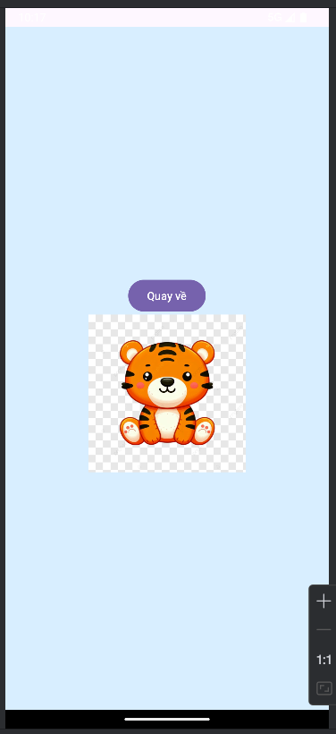
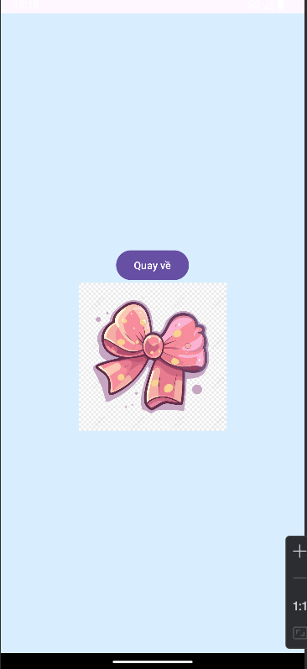
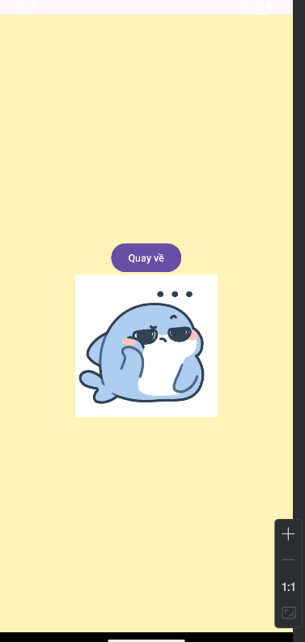
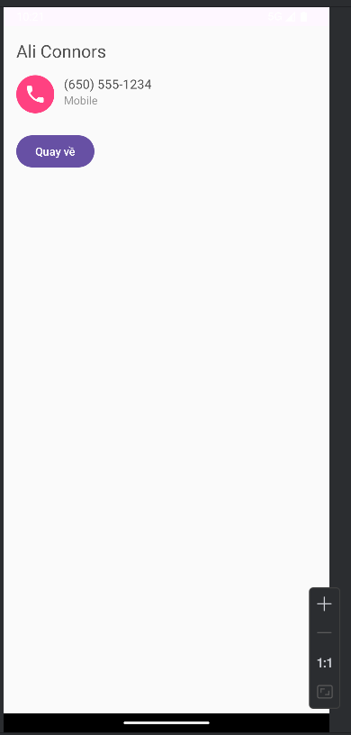
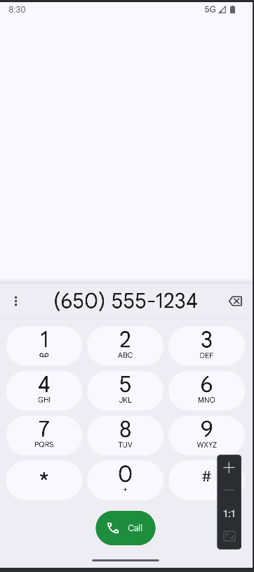
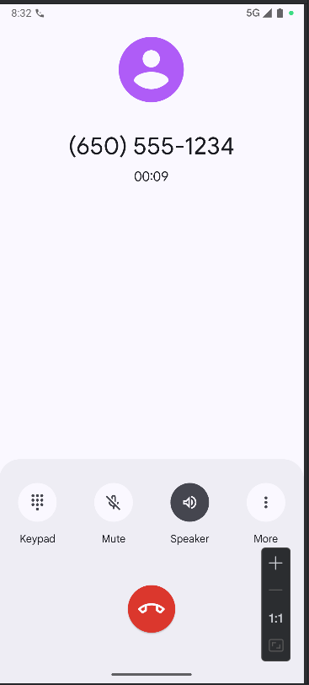

SOURCE CODE
Activity_main.xml
<?xml version="1.0" encoding="utf-8"?>
<LinearLayout xmlns:android="http://schemas.android.com/apk/res/android"
android:layout_width="match_parent" android:layout_height="match_parent"
android:orientation="vertical" android:padding="24dp" android:gravity="center">
<Button
android:id="@+id/btnSplash"
android:layout_width="match_parent"
android:layout_height="wrap_content"
android:text="Mở BT1: Splash" />
<Button
android:id="@+id/btnLoading"
android:layout_width="match_parent"
android:layout_height="wrap_content"
android:layout_marginTop="12dp"
android:text="Mở BT2: Loading" />
<Button
android:id="@+id/btnProfile"
android:layout_width="match_parent"
android:layout_height="wrap_content"
android:layout_marginTop="12dp"
android:text="Mở BT3: Profile" />
</LinearLayout>
MainActivity
package com.example.lap08.ui
import android.content.Intent
import android.os.Bundle
import android.widget.Button
import androidx.appcompat.app.AppCompatActivity
import com.example.lap08.R
class MainActivity : AppCompatActivity() {
override fun onCreate(savedInstanceState: Bundle?) {
super.onCreate(savedInstanceState)
setContentView(R.layout.activity_main)
findViewById<Button>(R.id.btnSplash).setOnClickListener {
startActivity(Intent(this, M000ActSplash::class.java))
}
findViewById<Button>(R.id.btnLoading).setOnClickListener {
startActivity(Intent(this, M001ActLoading::class.java))
}
findViewById<Button>(R.id.btnProfile).setOnClickListener {
startActivity(Intent(this, M001ActProfile::class.java))
}
}
}
AndroidManifest
<?xml version="1.0" encoding="utf-8"?>
<manifest xmlns:android="http://schemas.android.com/apk/res/android">
<application
android:allowBackup="true"
android:icon="@mipmap/ic_launcher"
android:label="@string/app_name"
android:roundIcon="@mipmap/ic_launcher_round"
android:supportsRtl="true"
android:theme="@style/Theme.Lap08">
<activity android:name=".ui.M001ActProfile" />
<activity android:name=".ui.M001ActLoading" />
<activity android:name=".ui.M000ActSplash" />
<!-- MainActivity có intent-filter nên PHẢI có exported khi targetSdk >= 31 -->
<activity
android:name=".ui.MainActivity"
android:exported="true">
<intent-filter>
<action android:name="android.intent.action.MAIN" />
<category android:name="android.intent.category.LAUNCHER" />
</intent-filter>
</activity>
</application>
</manifest>

